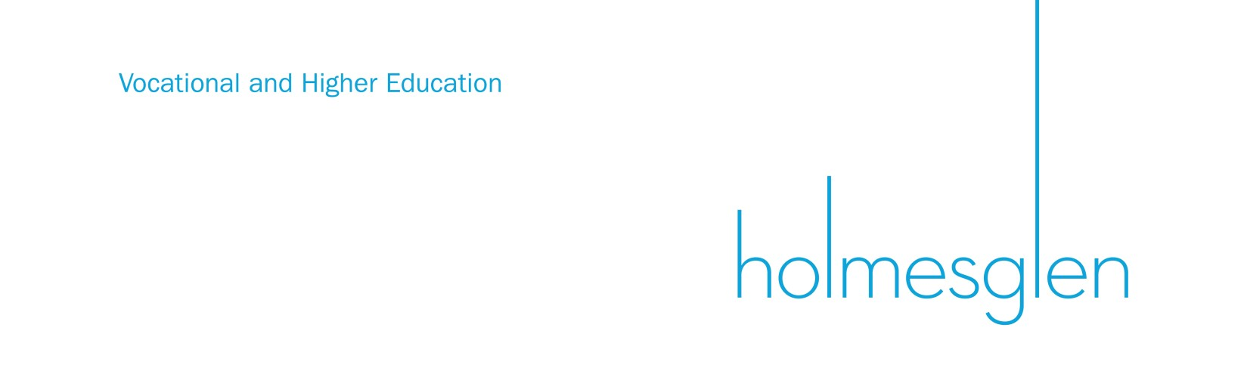

Holmesglen credit arrangements with other education providers

Holmesglen has partnership arrangements with other educational institutions that enable students who complete qualifications at these institutions to be granted credit towards Holmesglen’s degrees.

Detailed below are the organisations and their programs that are given credit into specific Holmesglen degree programs.

Provider | Course | Maximum credit point exemption | Minimum time to complete degree with credits | Holmesglen Degree title
SEDA Group | SIS50612 Diploma of Sport Development | 30 Credit points  (5 Subjects) | 2.5 years | Bachelor of Sport Business

